James River Runners

River Runners Technologies

Erik Tiltman – Project Manager

Chris Calbi – Business Analyst

Ronny Georgi – Systems Analyst

Adam Noonan – Programming Coordinator

**MIS 4173 Information Systems Development & Implementation**

**Dr. Eric Kisling**

**Milestone 3**

Contents

[Project Description 5](bookmark://_Toc3402565#_Toc3402565)

[Executive Summary 5](bookmark://_Toc3402566#_Toc3402566)

[Project Plan 5](bookmark://_Toc3402567#_Toc3402567)

[Business Overview 5](bookmark://_Toc3402568#_Toc3402568)

[Current Environment 5](bookmark://_Toc3402569#_Toc3402569)

[Proposed System Objectives & Constraints 6](bookmark://_Toc3402570#_Toc3402570)

[Expected Benefits 7](bookmark://_Toc3402571#_Toc3402571)

[Stakeholders 7](bookmark://_Toc3402572#_Toc3402572)

[Context Diagram 7](bookmark://_Toc3402573#_Toc3402573)

[Use Case Package 8](bookmark://_Toc3402574#_Toc3402574)

[Use Case Diagram 8](bookmark://_Toc3402575#_Toc3402575)

[System Design 8](bookmark://_Toc3402576#_Toc3402576)

[Complete Data Flow Diagram (DFD) Package 9](bookmark://_Toc3402577#_Toc3402577)

[DFD Level 0 9](bookmark://_Toc3402578#_Toc3402578)

[Account Creation DFD Level 1 9](bookmark://_Toc3402579#_Toc3402579)

[Order Request DFD Level 1 10](bookmark://_Toc3402580#_Toc3402580)

[Customer Order History Request DFD Level 1 10](bookmark://_Toc3402581#_Toc3402581)

[Owner Analytics Request DFD Level 1 11](bookmark://_Toc3402582#_Toc3402582)

[Detailed Non-Functional Requirements 11](bookmark://_Toc3402583#_Toc3402583)

[Programming Plan 12](bookmark://_Toc3402584#_Toc3402584)

[Hardware & Software Specification 14](bookmark://_Toc3402585#_Toc3402585)

[Navigation Diagram 15](bookmark://_Toc3402586#_Toc3402586)

[Mockup Forms and Reports 16](bookmark://_Toc3402587#_Toc3402587)

[**Owner – Overview** 20](bookmark://_Toc3402588#_Toc3402588)

[Sample Reports with Data 20](bookmark://_Toc3402589#_Toc3402589)

￼

￼

[Entity Relationship Diagrams (ERDs) 22](bookmark://_Toc3402592#_Toc3402592)

[Standard Naming Conventions 23](bookmark://_Toc3402593#_Toc3402593)

[Appendix A: Project Timeline 23](bookmark://_Toc3402594#_Toc3402594)

[Appendix B: Use Cases 23](bookmark://_Toc3402595#_Toc3402595)

# Project Description

## Executive Summary

Our project team for the capstone MIS 4173 project have been given the tasks up updating the system for James River Runners, owned by David McCallum. After finishing up our analysis phase of the project, our team then moved onto the design phase. This is the first phase of our project in which we were able to develop various diagrams based on our BPA system that we have started to put into start with James River Runners. We developed a DFD Package, a Navigation diagram, a programming plan, an ERD and various other pieces for our design phase, that will help us to line up for the implementation phase will be in the coming months. In this design, we have made it available to work with two aspects of our system. The first being the alert system, which will alert the owner of when a package is to be delivered and the specific time and date of the delivery. The second part of the system, is to set up an online form through a website we made, that allows the costumer to fill out order forms online to take away the pressure of constant phone contact, which is currently how the company operates with its customers and employees. With these two specifications in mind, we have developed our system design to consider these specific aspects, that we will be implementing in the future.

## Project Plan

## Business Overview

James River Runners a legal document carrier company located in Richmond, Virginia has grown exponentially since the beginning of the company back in 1999. As the company has grown more and more responsibility has been put on the owner, David McCallum. With the growth of the company there has been a growing need for advancements in the process of how the business is run. After talking many times with the owner David, we were able to decide that there are two main issues that needed to be solved for the company to have continued competitive advantage in the market. The first was to set up an alert system that allowed the owner to receive messages based off when the customer needs a document delivered. the next problem we were able to solve was to set up an online form through a website we made, that allowed the costumer to fill out order forms online to take away the pressure of constant phone contact, which is currently how the company operates. With this we were able to move on to the design phase of our project and begin setting up the system we intend to implement in the coming months.

## Current Environment

When we look at the current environment of James River Runners, everything on the business process aspect of the company is completed manually and orders are made completely in accordance with the cellphone of David McCallum. They currently have no information systems in place and all parts of the company including accounting, logistics, and ordering are subject to manual labor either done by the owner or completed by the members of Dave’s team.

Working with Dave McCallum has given our team a wonderful chance to set up the first BPA system that will not only benefit for Dave but will benefit for the entire company to have their first system put in place. Because there are no current systems, our team was able to set a system of free of current system integration.

## Proposed System Objectives & Constraints

Working with James River Runners to solve their business need, our team is creating a Business Process Automation System that will convert his manual, paper-based business processes and documentation in to an easy-to-use information system. The business objectives of this system include processing orders through the company’s first website and creating a system that alerts the owner to instances such as new accounts created, orders, and inquiries. Runners will be notified of new orders as soon as they are processed. Customers will be notified on the status of their order from initial confirmation alerts to electronic invoices and receipts after delivery. A customer will create an account and view order history through the website. In addition, individual customer and order data as well as total statistics will be available for owner Dave McCallum to view. While the company’s “runners” will still be transporting legal documents from one location to another via physical transport, the entire system around them will be automated. Upon consulting with company owner Dave McCallum about his goals for the project, we have determined the requirements and constraints as follows:

Functional Requirements:

* + Website with company background and information
  + Log-in portal for customers, runners, and owner
  + Customer must be able to enter order information
  + Customer receives order confirmation via email
  + Customer receives delivery confirmation & receipt via email
  + Runners must be able to enter expenses incurred

Non-functional Requirements:

* + Availability 24 hours per day, 365 days per year
  + Run on all commonly used web browsers such as Internet Explorer, Mozilla Firefox, Safari, Google Chrome, and Opera
  + Maintain full functionality and display properly on any common mobile web browser
  + Orders must be limited to Central and Eastern Virginia
  + Automated backup of customer data
  + Displayed screen must refresh within 2 seconds
  + Apache Server with MySQL

Constraints:

* + Analysis presentation (2/12)
  + Design presentation (3/14)
  + Structured walkthrough (3/26)
  + Training presentation (4/09)
  + Final presentation (4/30)

## Expected Benefits

Overcoming our constraints is vital to project success and we are extremely confident that we will be able to overcome them while maintaining all functional and non-functional requirements. There are a variety of benefits that will James River Runners will gain from upon implementation of our system. First, the automation will eliminate the need for the owner to manually fill out orders using pen and paper. Now, instead of customers having to get in direct contact with Mr. McCallum via phone, they will make orders online. This allows them to request legal documents any time of day regardless of company operating hours. No longer required to man the telephone, this system frees the owner to focus on other work-related endeavors while the runners transport documents. Runners who will no longer carry physical documentation or receipts to confirm the delivery and payment, only the legal documents requested. Order status and data being updated in real-time means that ownership can make business decisions faster than ever. Furthermore, we believe that giving James River Runners a web presence for the first time will give them the ability to significantly increase their profits now that they have a true website and can be contacted in more ways than simply via telephone.

## Stakeholders

The legal document carrier company James River Runners located in central Virginia, has various stakeholder’s that will be affected by our new system and will have to transition with the ways of our system we are putting in place. The first being the Owner, David McCallum. Then we have the costumers located in Richmond and its surrounding areas requesting a delivery, our project team that is working on this system and of course the runners who deliver the requested order at specific times throughout the year.

## Context Diagram

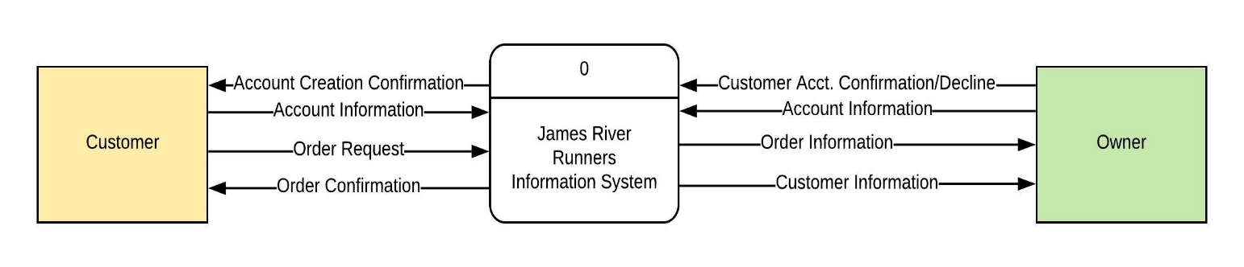

# Use Case Package

## Use Case Diagram

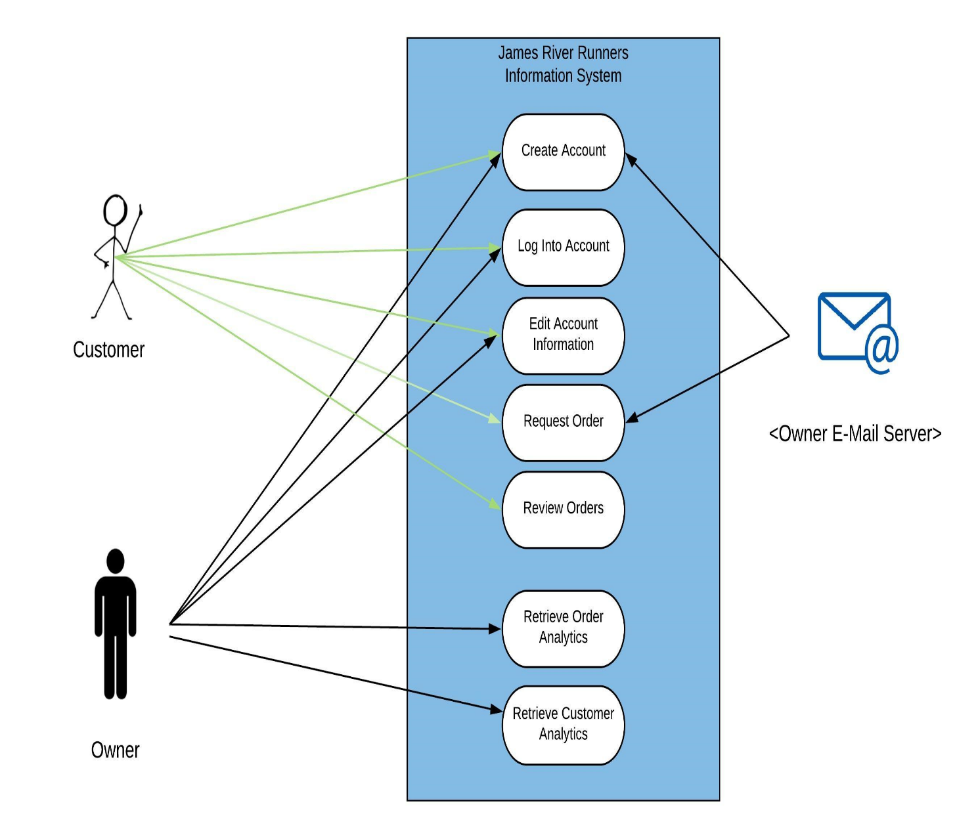

# System Design

Below contains our system design package that will be used to help the implementation of our system. We have a complete data flow diagram package that shows the process that our system will go through and the flow of how the information will go through each process. Our package contains a level 0 diagram and a level 1 diagram, used to set up the implementation of the automated system for James River Runners.

## Complete Data Flow Diagram (DFD) Package

### DFD Level 0

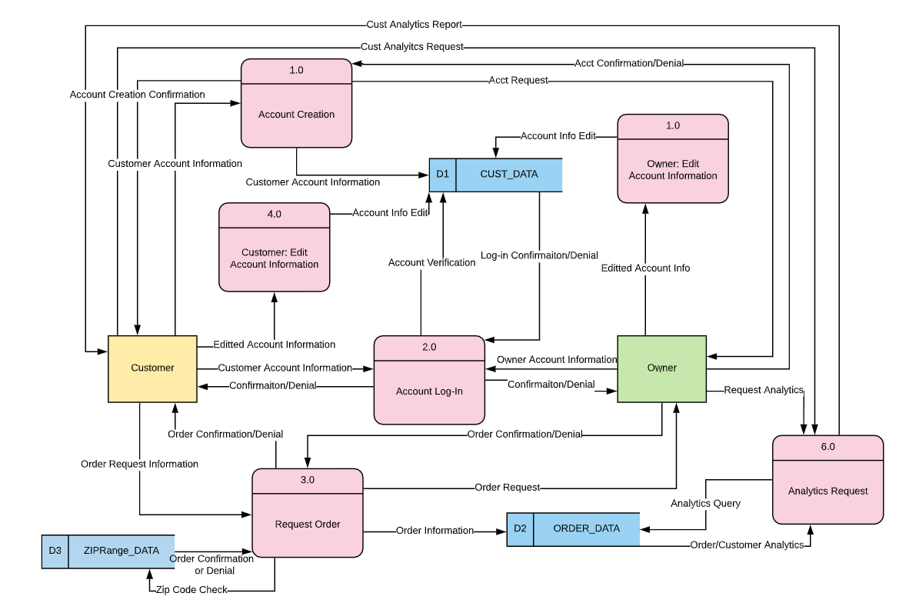

### Account Creation DFD Level 1

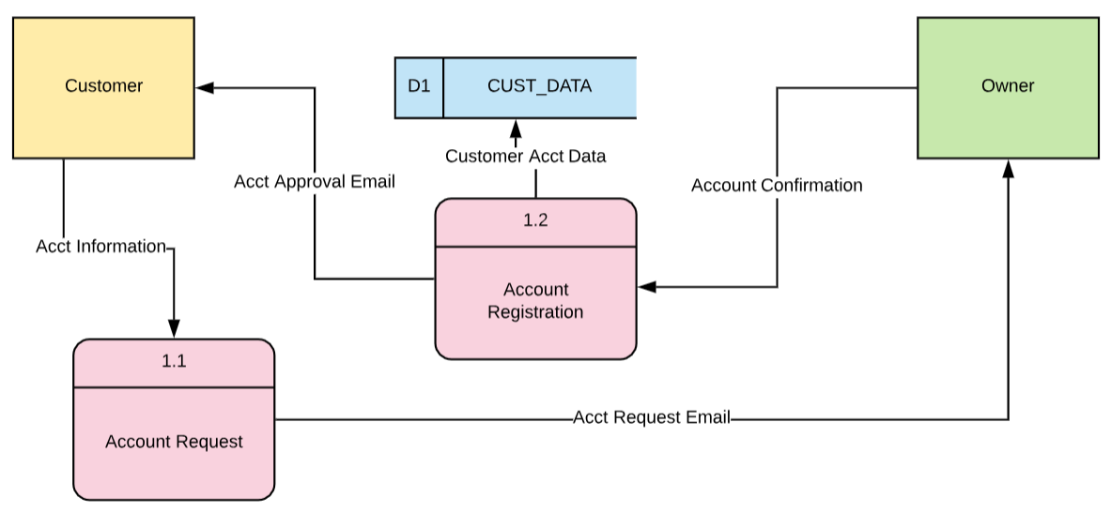

### Order Request DFD Level 1

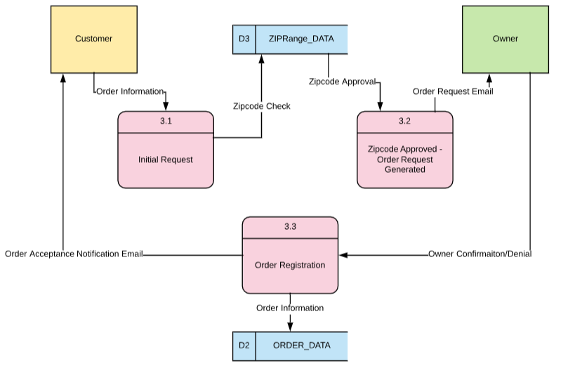

### Customer Order Analytics Request DFD Level 1

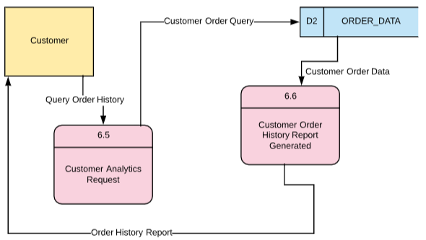

### Owner Analytics Request DFD Level 1

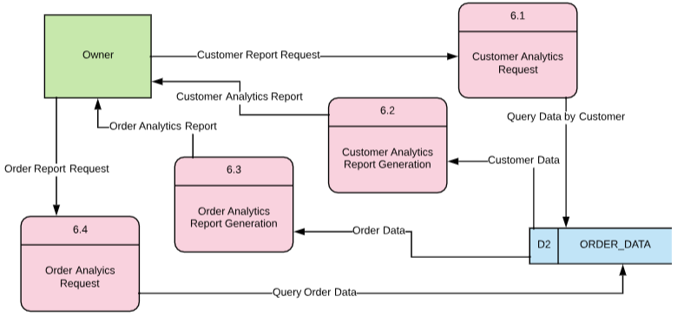

## Detailed Non-Functional Requirements

In order to improve upon the current system, this new information system must be available for customers to request an order 24 hours a day, seven days a week, 365 days a year. The website should be accessible, legible and operational on all major internet browsers, including mobile devices. The system must also automatically limit orders to the businesses area of operation (central Virginia), and this will be accomplished by comparing the intended order’s pick-up and delivery zip-codes to a list of acceptable inputs. The system must also contain a mechanism for vetting potential customer accounts; we don’t want just anyone to be able to order a delivery without providing payment information. This will be accomplished by sending an “Account Request” confirmation email to the Owner, who can either confirm or deny the potential customer’s account through email. The system must also automatically back-up customer order data. The website will be hosted via Apache Server, with data stored in a MySQL database.

## Programming Plan

|  |  |  |  |
| --- | --- | --- | --- |
| **Program Plan** | **Input** | **Process** | **Output** |
| Account Registration |  |  |  |
| Account Request | -Client First Name, Last Name, Address, City, Zip, Email address, phone number & password | -Client fills in fields  -If required fields are completed & valid, account request email sent to Owner  -If fields are not completed or invalid, Client is notified | -Account Creation Request email sent to Owner |
| Account Confirmation/Decline | -Account Creation Request email | -Owner confirms or declines the creation of new client account  -If confirmed, account information is added to Client database & log-in credentials provided | -If the account is confirmed by Owner, a confirmation email is sent to Client w/ log-in credentials  -If the account is declined, process ends with no notification |
| Account Creation Notification | -Account Creation Confirmation from Owner | -Email is generated for client notifying them of their successfully created account | -Account Creation Notification sent to Client |
| Account Log-in | -Account email & password | -If valid Client credentials provided, Client logs in  -If valid Owner credentials provided, Owner logs in  -If invalid credentials provided, log-in fails with notification | -Owner/Client logged in or notification of invalid email/password |
| Order Placement |  |  |  |
| Request Order | -Pick-up & drop-off location, date & time for pick-up, number of documents, package type & any additional notes | -If required fields are completed & valid (zip code check), Order Request email generated  -If required field are incomplete or invalid, notification to Client generated | -Order Request email to Owner or notification of invalid input to Client |
| Zip Code Check | -Order Pick-up & Drop-off Zip codes | -Query to ZIPRange_DATA to see if requested order is in area of operation | -Order process continues or is denied before request is sent to owner |
| Order Request to Owner | -Order Request email to Owner, Owner confirms or declines with optional notes | -Owner either confirms or declines the order  -On confirmation, order info added to the database & confirmation email to Client  -On order denial, denial email to Client | -Order Confirmation or Denial email to Client |
| Order Placement Notification | -Order Confirmation from Owner | -Email generated for Client confirming or denying their order | -Order Confirmation/Denial email |
| Edit Account Information |  |  |  |
| Edit Account Info | -Change to any account information field that was initially required at Account Creation | -If valid change, Account information is edited in database  -If invalid change (removal of required field, invalid zip code), notification to user generated | -If valid change, database edit  -If invalid, notification to user |
| Delete Account | -Client selects ‘Delete Account’, Confirms their desire to delete account & re-enters password | -Account information is deleted from database, notification of account removal sent to Owner  -Confirmation email to Client | -Account removal email to Owner  -Account deletion confirmation sent to Client |
| Retrieve Data |  |  |  |
| Customer: Order History | -Logged in Client selects ‘My Orders Page’ | -Webpage retrieves order information for that client from database | -Order history from database presented to Client |
| Owner: Customer Analytics | -Logged in Owner selects ‘Customer Statistics’ | -Webpage retrieves information on Clients (Name, Order Amounts, Location Distribution, Frequency of Order, Monthly development) | -All Client account information from database presented to Owner |
| Owner: Order Analytics | -Logged in Owner selects ‘Order Statistics’ | -Webpage retrieves information on past & present orders (Total Order Amount, Monthly development, Weekly development) | -All order information from database presented to Owner |

## Hardware & Software Specification

The information system will be created using Apache Server with MySQL. Software specifications require that a customer utilize one of the commonly used web browsers such as Internet Explorer, Mozilla Firefox, Safari, Google Chrome, or Opera to access James River Runners’ website and order portal. Therefore, the system must maintain full functionality when accessed through any of the above browsers. The system must maintain availability 24 hours per day, 365 days per year. It is also imperative that the software contain a backup for customer data in order to protect against any disruptions that may occur. Furthermore, any user (customer, runner, owner) must utilize a laptop/desktop computer or mobile device with internet connection to access James River Runners’ website.

## Navigation Diagram

Our navigation Diagram for James River Runners looks at the interaction among the portal of our website and the way it works with our BPA system that we are implementing. With this diagram our client will be able to visually see the various ways in which the homepage interacts with other segments required for our system.

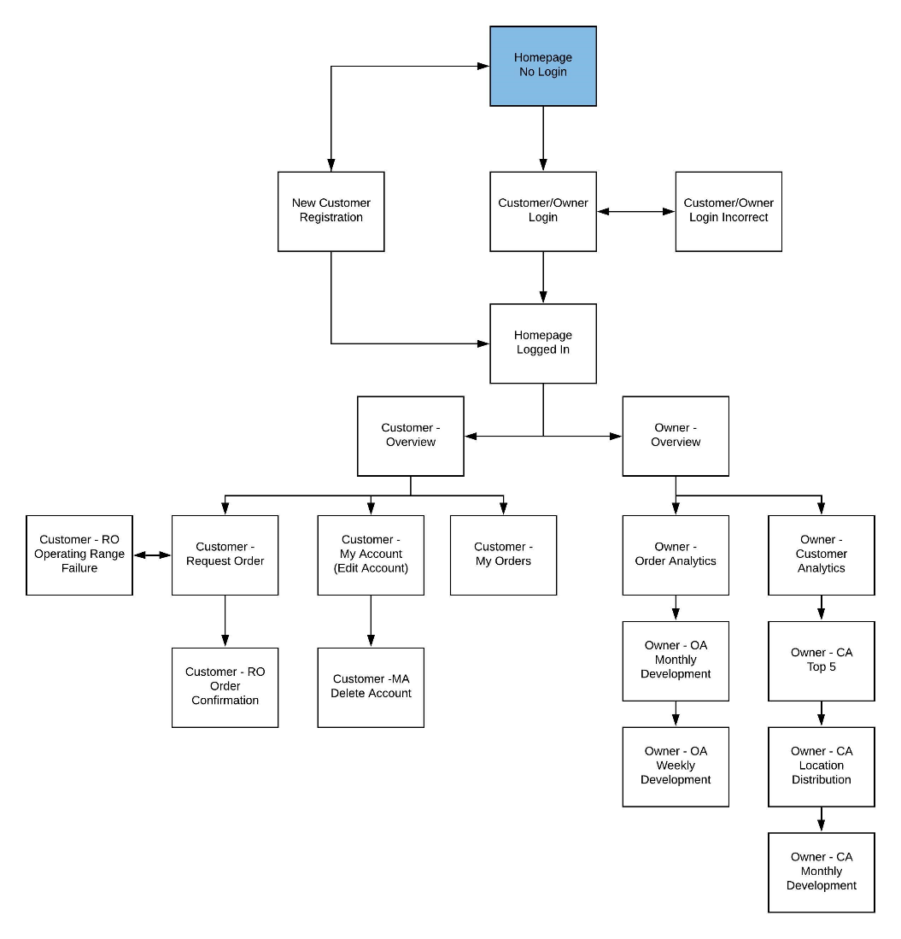

## Mockup Forms and Reports

This contains the screenshots of our website that we designed for James River Runners. Our team is looking to use this as the structure as we continue moving forward into the implementation phase of our project. We have various screenshots starting from our homepage and moving all the way around as seen from our navigation diagram above.

**Homepage No Login**

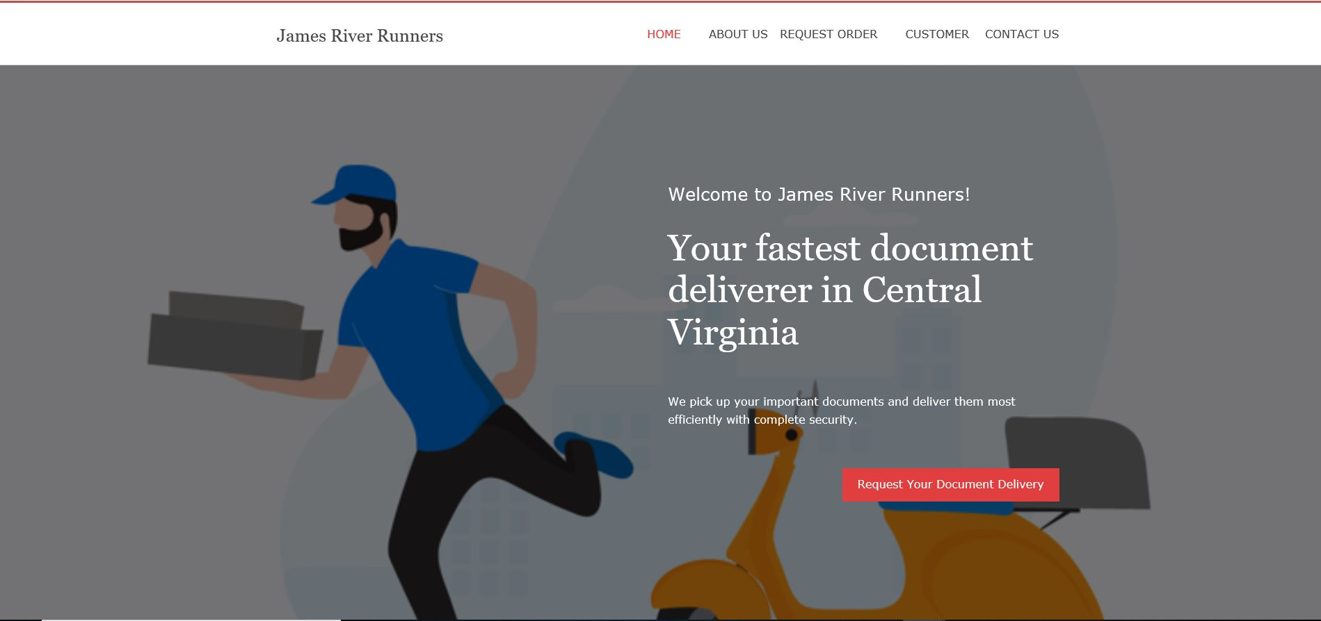

**New Customer Registration**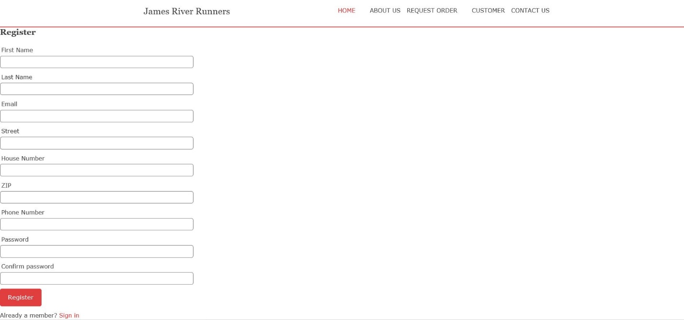

**Customer/Owner Login** 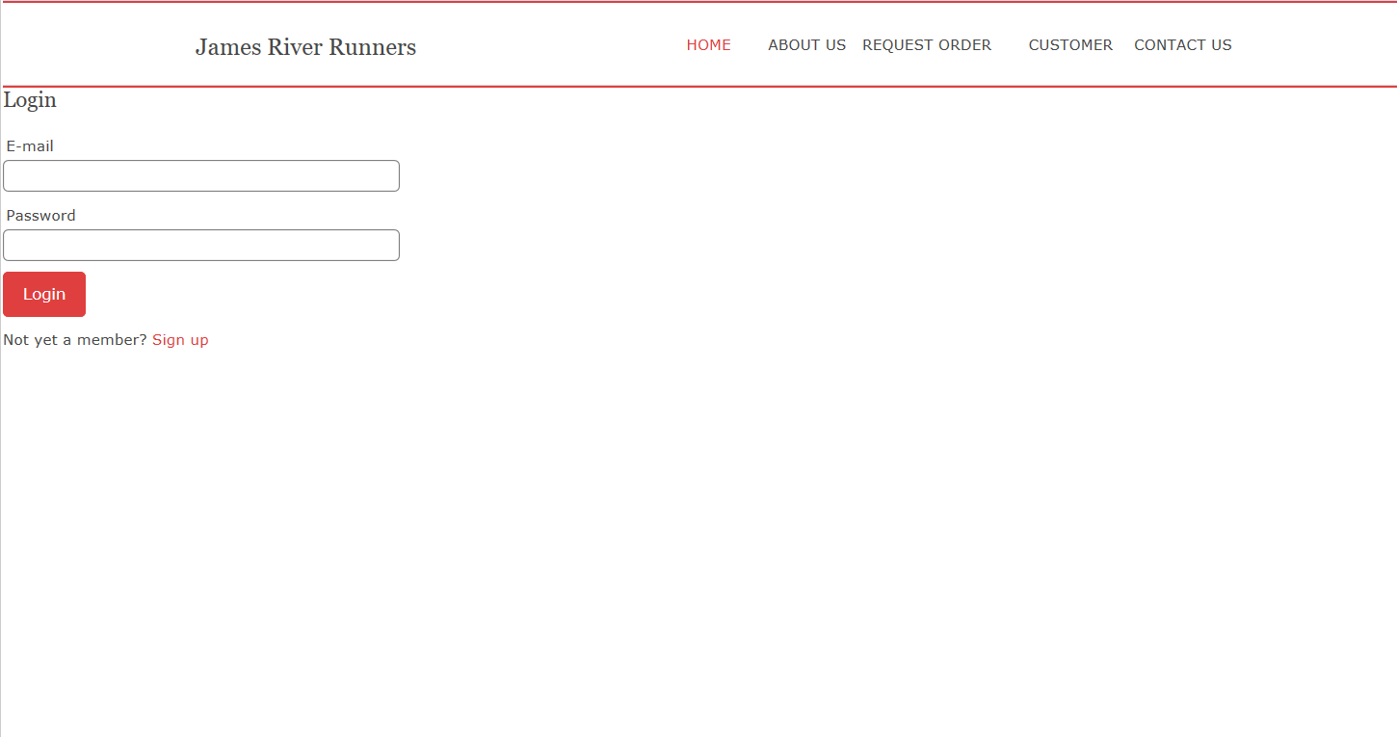

**Customer/Owner Login Incorrect**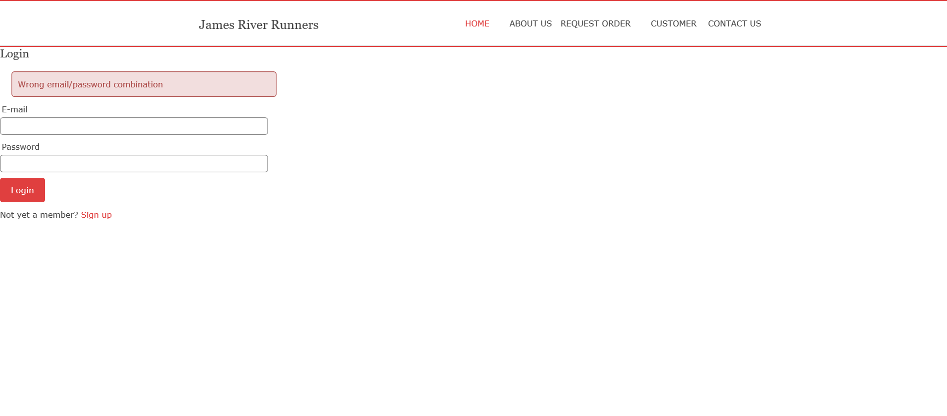

**Homepage Logged In**

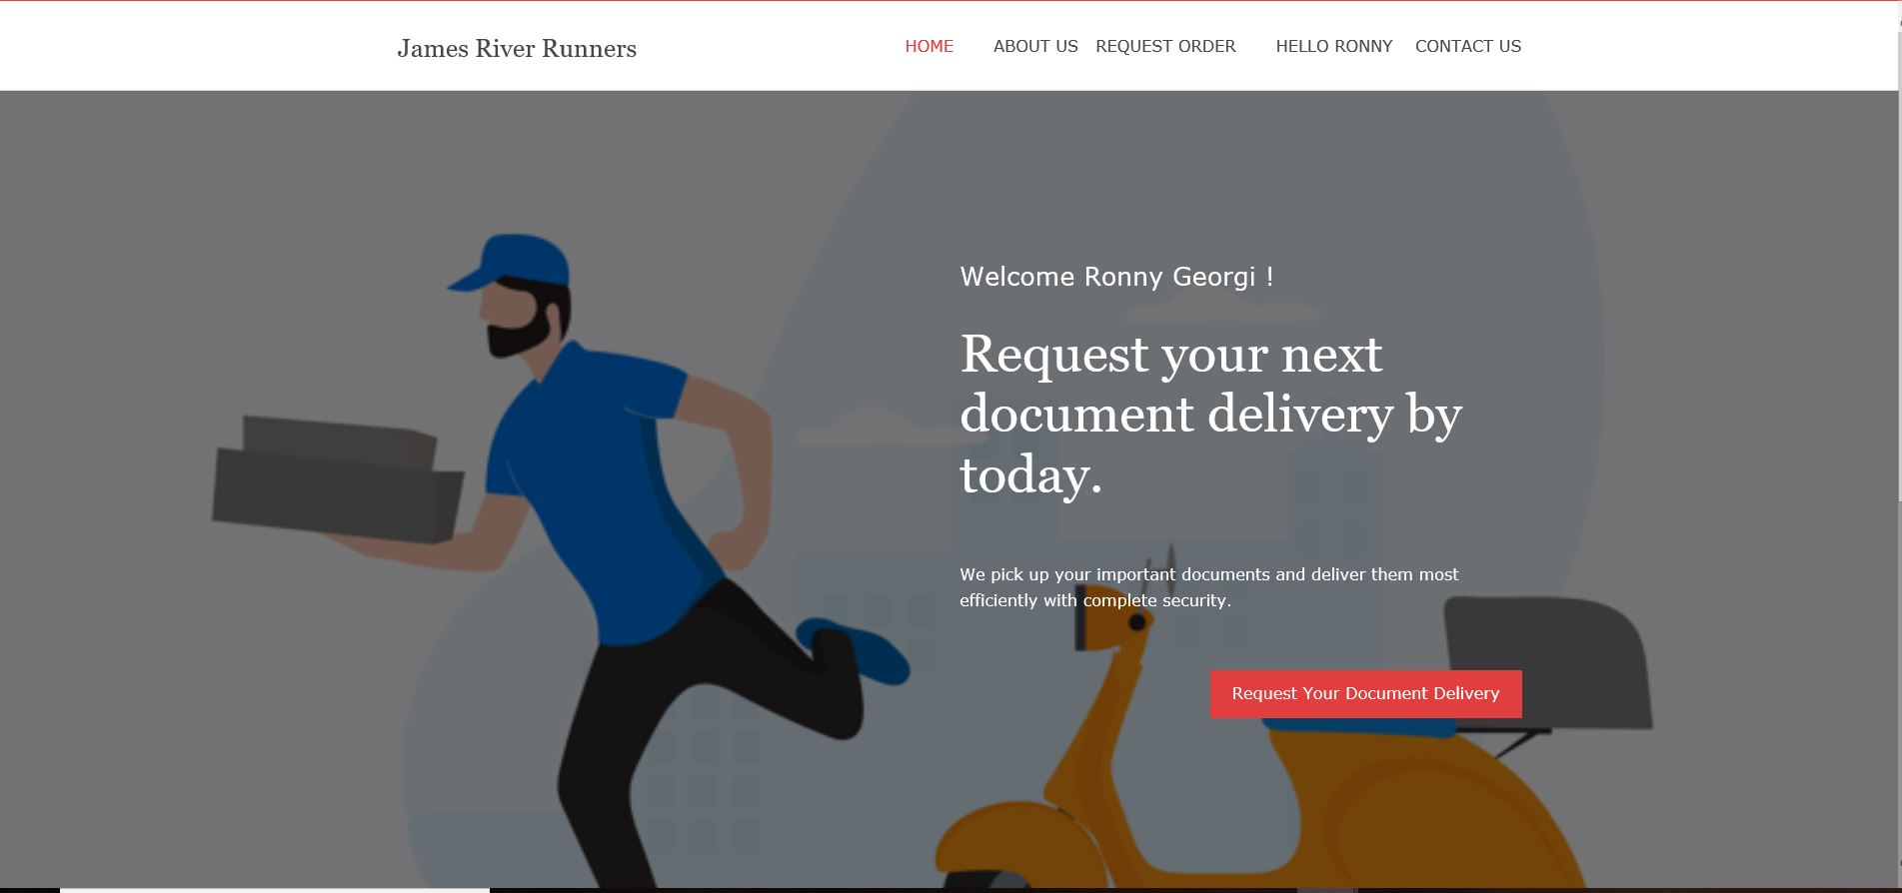

**Customer – Request Order**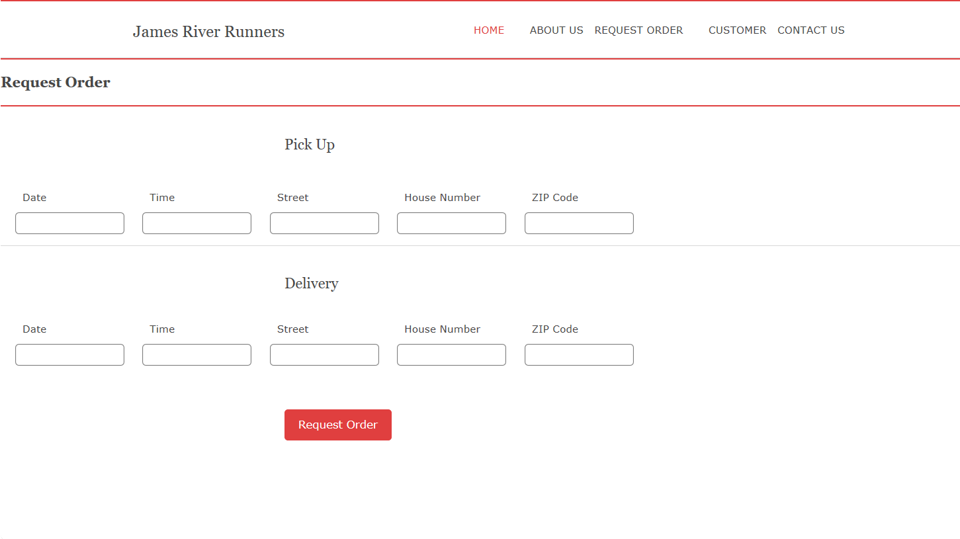

**Customer – Order Confirmation**

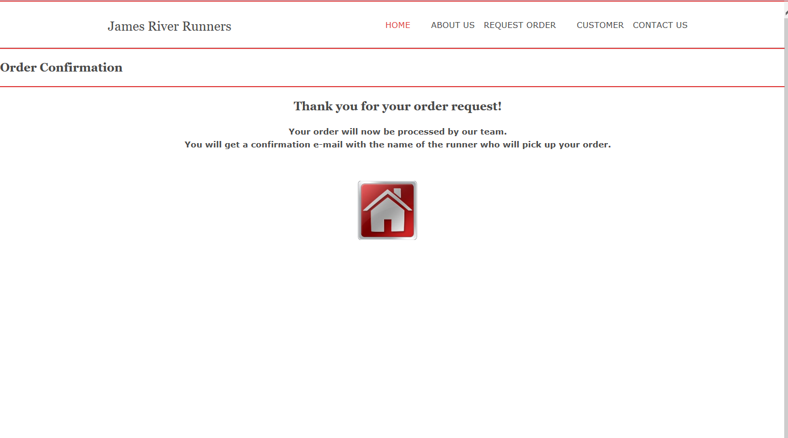

**Customer - My Account (Edit Account)**

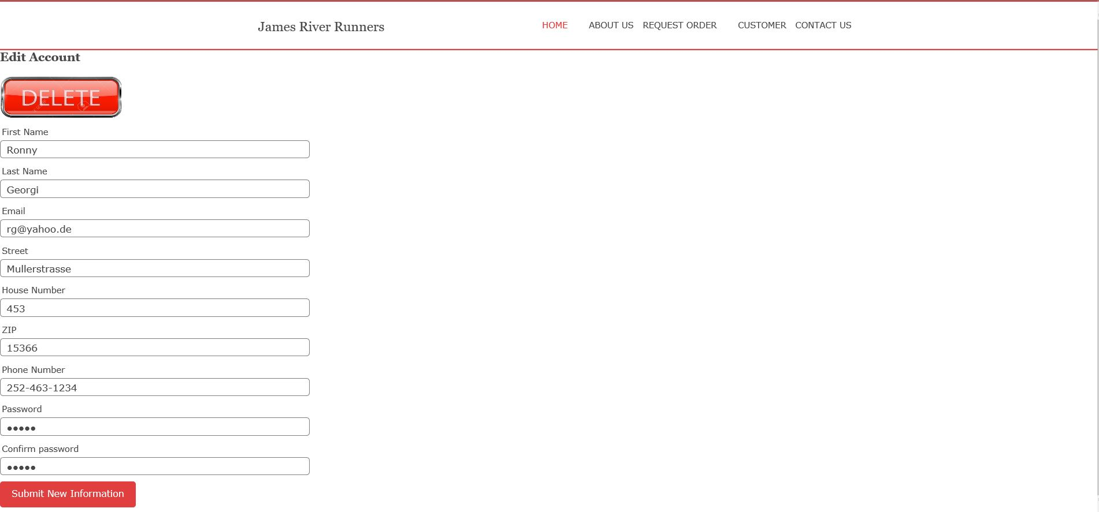

**Customer – Delete Account**

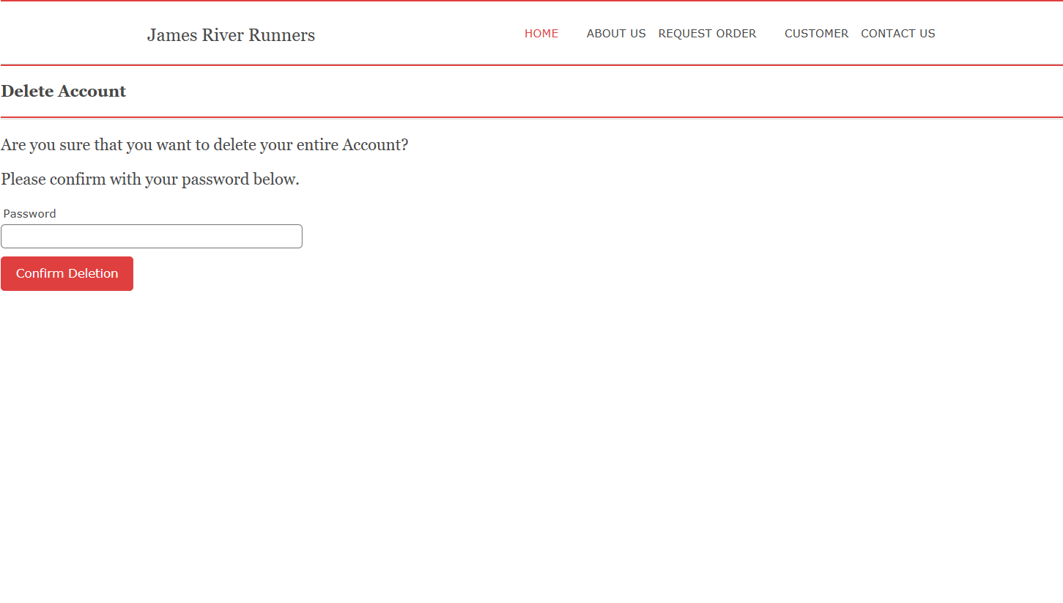

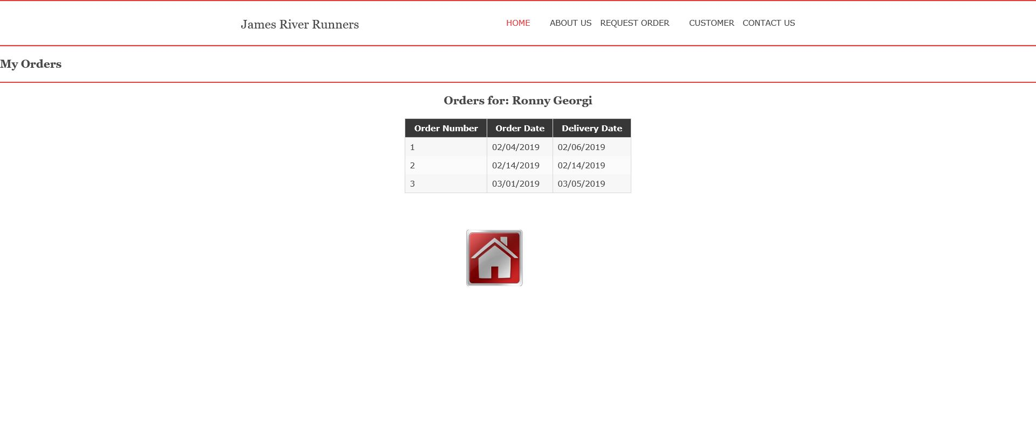**Customer - My Orders**

**Owner – Overview**

## Sample Reports with Data

This section of our design includes dummy data that is used to show the process of making an order through the website and the analytics that come back on the other side that will be used for the owner David McCallum. We have analytics that contain the order data the data of the customers and what they have completed in terms of amount of orders, and a graph of distributions for the company to use for marketing and competitive advantage purposes.

**Order Analytics**

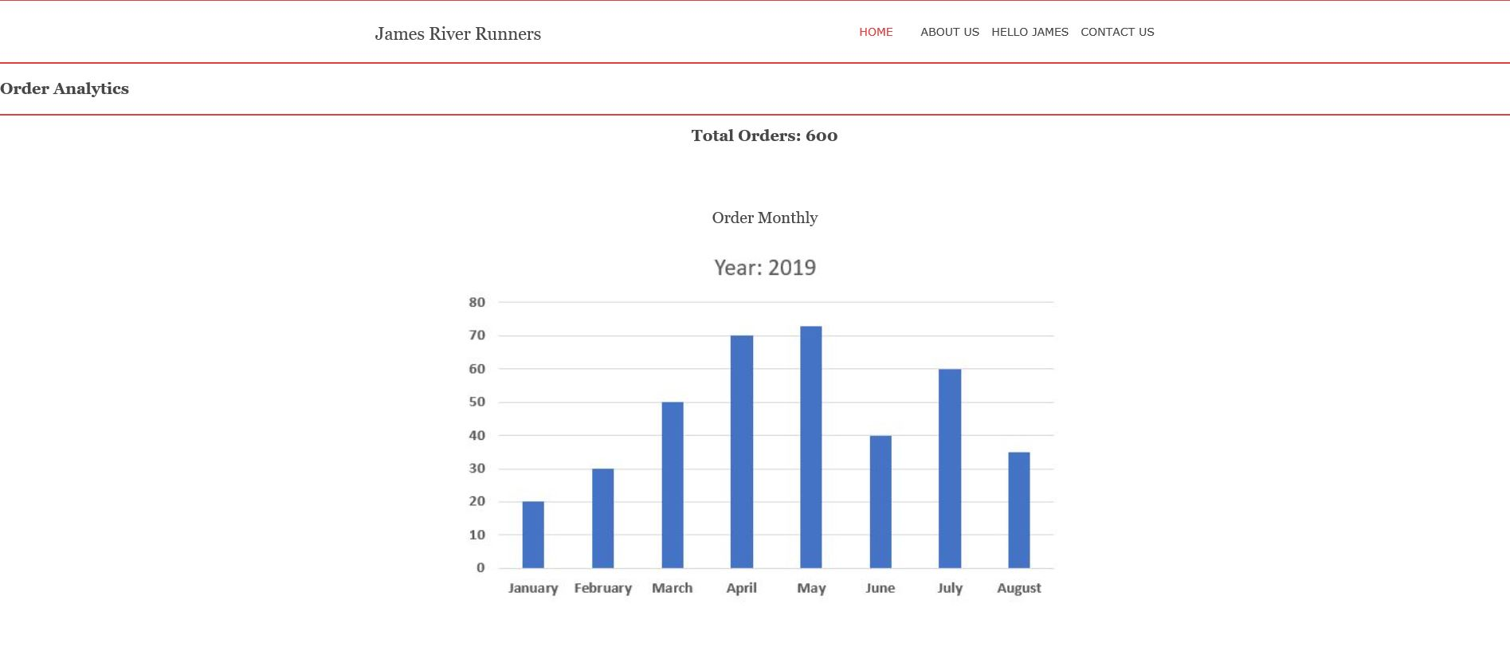

**Customer Analytics**

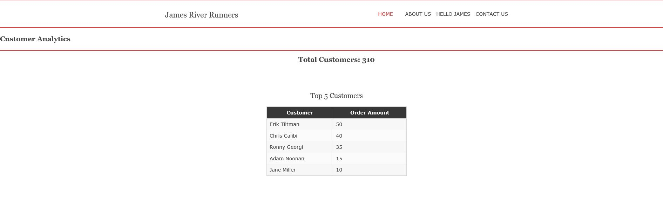**Customer Analytics**

## 

## 

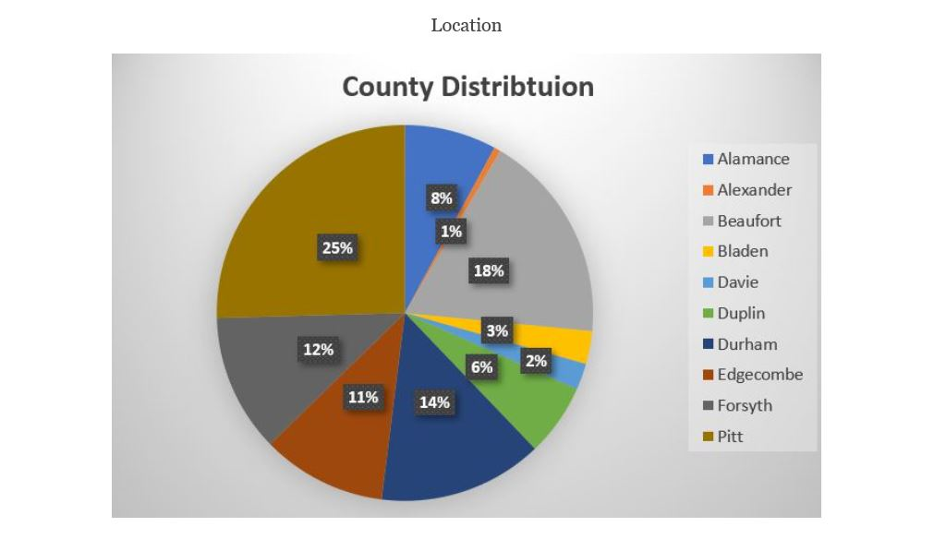

## Entity Relationship Diagrams (ERDs)

This contains the relationship of the entities we intend to use for the programming our automated system. As we can see below, we have a relationship that comes from the ordering of the data that comes into line with the customer data for James River Runners

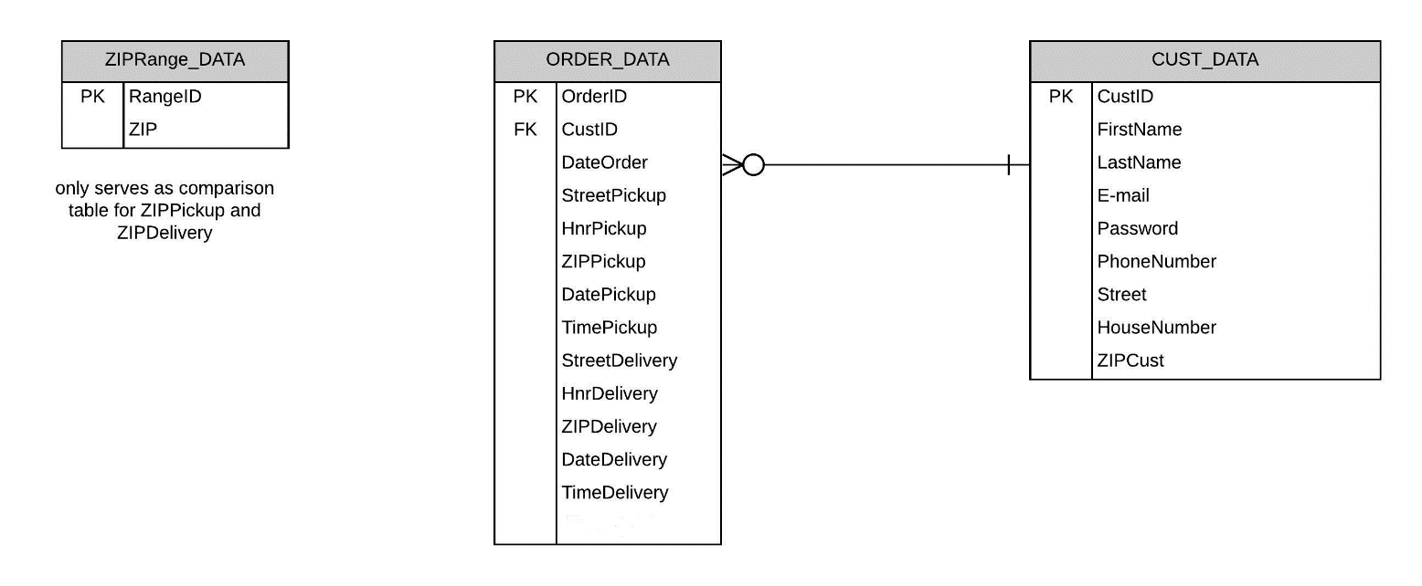

# Appendix A: Project Timeline

# Appendix B: Use Cases

## Use Case Specification: Create Account

|  |  |  |  |  |  |  |
| --- | --- | --- | --- | --- | --- | --- |
| **Use Case Name:**  Create Account | | | | **ID:**  UC-1 | | **Priority:**  High |
| **Actor:** Customer/Owner | | | | | | |
| **Description:** Unregistered User goes through account registration process | | | | | | |
| **Trigger:** Customer selects “Sign Up” button from Drop-down menu **Type:**  External  Temporal | | | | | | |
| **Preconditions:**   1. User is not logged into an account. 2. User is at website’s homepage. | | | | | | |
| **Normal Course:**   * 1. Customer selects “Create Account” button from drop-down menu.   2. Customer enters required information.   3. System processes request & sends verification   request to owner.  4.0 Confirmed Customer account is generated;  relevant data fields stored | | | **Information for Steps:**  Client Information: LName, FName, Address, City, Zip, email, phone number  Account Request notification email  Client Information: LName, FName, Address, City, Zip, email, phone number | | | |
| **Alternative Courses:**   * 1. User input is missing a required field.   2. User receives notice to complete required fields.   2.0 The user provides invalid input.  2.1 User receives notice of invalid input provided.  3.0 The account registration request is denied by owner.  3.1 Account request is deleted with no notice given to user. | | | **Information for Alt. Course Steps:**  Notice of required fields  Notice of invalid input  Decline of Account Request  Decline of Account Request | | | |
| **Postconditions:**   1. A customer now has an account saved in our system and can log in. 2. Our database has customer account saved and is ready to store order data. | | | | | | |
| **Exceptions:** | | | | | | |
| **Summary Inputs:**  Client Information,  Confirmation or Deletion of Account Request | **Source:**  Customer/Owner | **Outputs:**  Account Request to Owner,  Confirmation email for Customer | | | **Destination:**  Customer Data Store | |

## Use Case Specification: Log Into Account

|  |  |  |  |  |  |  |
| --- | --- | --- | --- | --- | --- | --- |
| **Use Case Name:**  Log Into Account | | | | **ID:**  UC-2 | | **Priority:**  High |
| **Actor:** Customer/Owner | | | | | | |
| **Description:** Customer or Owner logs into respective account | | | | | | |
| **Trigger:** Log-in Attempt **Type:**  External  Temporal | | | | | | |
| **Preconditions:**   1. User is at website and not logged in. 2. User has a registered account username/email & password. | | | | | | |
| **Normal Course:**   * 1. Select “Log-In” from Drop-down Menu   2. User inputs account username & password.   3. System logs Customer into their account or Owner into Admin account. | | | **Information for Steps:**  Username & password  Log-in Confirmation | | | |
| **Alternative Courses:**   * 1. The username or password does not match a registered account.   2. User is asked to re-enter username & password or contact Owner for assistance.  1. The owner provides Admin username & password.   2.1 System logs Owner into Admin account. | | | **Information for Alt. Course Steps:**  Invalid username/password  Notification of Denial  Admin username & password  Log-in Confirmation | | | |
| **Postconditions:**   1. System now allows Customer to access request orders, view orders or edit account information. 2. System now allows Owner to retrieve order statistics or customer statistics. | | | | | | |
| **Exceptions:** | | | | | | |
| **Summary Inputs:**  Username & password  Invalid Username/password  Admin Username & password | **Source:**  Customer  Owner | **Outputs:**  Log-in Confirmation,  Notification of Denial | | | **Destination:**  Webpage | |

Use Case Specification: Request an Order

|  |  |  |  |  |  |  |
| --- | --- | --- | --- | --- | --- | --- |
| **Use Case Name:**  Request Order | | | | **ID:**  UC-3 | | **Priority:**  High |
| **Actor:** Customer | | | | | | |
| **Description:** Logged in customer requests a document delivery. | | | | | | |
| **Trigger:** Customer requests a delivery through website. **Type:**  External  Temporal | | | | | | |
| **Preconditions:**   1. User is already logged into verified customer account. | | | | | | |
| **Normal Course:**   * 1. Customer selects “Place an order” from drop-down menu   2. Customer enters required fields & submits order  1. Order Request email is sent to Owner   2.1 Owner confirms order or denies order  2.2 Order Confirmation email is sent to Customer  3.0 Order Information stored in Customer Data Store | | | **Information for Steps:**  Order Information: Pickup & drop-off location, date & time, number of documents, package type, extra notes.  Order Request email  Confirmed Order processed  Order Confirmation email  Customer Data Store updated with latest order | | | |
| **Alternative Courses:**   * 1. Owner denies order   2.0 Customer enters invalid input for required field  2.1 Customer receives Invalid Input notice | | | **Information for Alt. Course Steps:**  Order is not processed  Invalid Input notice | | | |
| **Postconditions:**   1. Order Information is confirmed and stored in Customer Data Store. 2. Order Information is accessible both by Owner & Client. | | | | | | |
| **Exceptions:** | | | | | | |
| **Summary Inputs:**  Order Information | **Source:**  Customer | **Outputs:**  Confirmed Order, Updated Customer Data Store | | | **Destination:**  Customer Data Store | |

## Use Case Specification: Edit Account Information

|  |  |  |  |  |  |  |
| --- | --- | --- | --- | --- | --- | --- |
| **Use Case Name:**  Edit Account Information | | | | **ID:**  UC3 | | **Priority:**  Medium |
| **Actor:** Customer, Owner | | | | | | |
| **Description:** The customer and owner are logged into the system. They want to change some previously entered information of their account. The customer also wants to delete his account if he decides that he doesn’t want to work with the company any more or he wants to create a new account later. | | | | | | |
| **Trigger:** The customer wants to edit his/her account information. **Type:**  External  Temporal | | | | | | |
| **Preconditions:**   1. The customer and owner (C&O) are logged in and their IDs are identified by the system. | | | | | | |
| **Normal Course:**  1.0 The customer and owner enter my account section   1. The C&O select my account 2. The system displays the current account information of C&O   2.0 The C&O edit existing account information   1. The C&O edit the desired fields 2. The C&O select Submit 3. The system asks for confirmation of changes 4. The C&O confirm changes in their account data 5. The system displays confirmation message 6. The system displays the logged in homepage   3.0 The customer wants to delete her/his account   1. In the My Account section the customer selects   Delete Complete Account   1. The system asks for confirmation of deletion 2. The customer confirms deletion of the account 3. The system asks for password verification 4. The customer enters her/his password and   verifies deletion   1. The system displays confirmation message 2. The system displays the logged off homepage | | | **Information for Steps:**  My Account Page  Current Account Information (Name. E-mail, Password, Address)  Editing of Fields (Account Information)  Submit  Confirmation Request  Confirmation, New Account Information  Confirmation Message  Logged in Homepage  Delete Complete Account  Confirmation Request  Confirmation  Password Verification Request  Password  Confirmation Message  Logged Off Homepage | | | |
| **Alternative Courses:**  2.1 The C&O submit the new account information  without having filled out all required fields  required data fields   1. The system displays message that all required   fields need to be filled out   1. The system marks the required unfilled fields 2. The C&O fill out all required fields 3. The system displays confirmation message 4. The system displays the logged in homepage | | | **Information for Alt. Course Steps:**  Missed Account Data  Info Message  Marked Fields  Filled Required Fields  Confirmation Message  Logged in Homepage | | | |
| **Postconditions:**  1. All updates in the account information are transferred correctly in the data storage. | | | | | | |
| **Exceptions:** | | | | | | |
| **Summary Inputs:**  Updated Account Information | **Source:**  Customer | **Outputs:**  Updated Account Information | | | **Destination:**  Customer, Customer Data Store | |

## Use Case Specification: Review Orders

|  |  |  |  |  |  |  |
| --- | --- | --- | --- | --- | --- | --- |
| **Use Case Name:**  Review Orders | | | | **ID:**  UC5 | | **Priority:**  Medium |
| **Actor:** Customer | | | | | | |
| **Description:** The customer is logged into the system. The Customer wants to see the document orders that she/he did with the company in the past. | | | | | | |
| **Trigger:** The customer wants to see the past orders. **Type:**  External  Temporal | | | | | | |
| **Preconditions:**   1. The customer is logged in and her/his ID is identified by the system. | | | | | | |
| **Normal Course:**  1.0 The customer enters my orders section   1. The Customers selects my orders 2. The system displays a summarized overview of   all orders  2.0 The customer wants to see all details about a specific  past order   1. The Customer selects All Details next to the   order   1. The system displays all details to the specific   order  3.0 The customer wants to see all orders together again   1. The customer selects Back To All Orders 2. The system displays a summarized overview of   all orders | | | **Information for Steps:**  My Orders Page  All orders summarized  All Details  All Order Data (Doc. Type, Order & Delivery Date, Pick-Up & Delivery Location)  Confirmation  Back To All Orders  All orders summarized | | | |
| **Alternative Courses:**  1.1 The customer wants to see past orders, but hasn’t  made any orders under the current account yet  fields need to be filled out   1. The Customers selects my orders 2. The system displays a blank page with a text information that no orders have been made yet | | | **Information for Alt. Course Steps:**  My Orders Page  Blank page, text info | | | |
| **Postconditions:**  1. All past orders for the specific account have been stored correctly in the data storage. | | | | | | |
| **Exceptions:** | | | | | | |
| **Summary Inputs:**  My Orders request | **Source:**  Customer | **Outputs:**  Order overview & details | | | **Destination:**  Customer, Order Data Store | |

## Use Case Specification: Retrieve Customer Statistics

|  |  |  |  |  |  |  |
| --- | --- | --- | --- | --- | --- | --- |
| **Use Case Name:**  Retrieve Customer Statistics | | | | **ID:**  UC6 | | **Priority:**  Medium |
| **Actor:** Owner | | | | | | |
| **Description:** The owner is logged into the system. He wants to see various statistics about the structure of his customer base. | | | | | | |
| **Trigger:** The owner wants to see customer statistics. **Type:**  External  Temporal | | | | | | |
| **Preconditions:**     1. The system is up to date and online. 2. The owner is logged in and his ID is identified by the system. 3. Multiple customers have already been entered in the customer database. | | | | | | |
| **Normal Course:**  1.0 The owner enters the customer statistics section   1. The owner selects on Customer Statistics 2. The system displays a list with all customers and shows the total customer amount   2.0 The owner wants to see his top five customers   1. The owner selects Top 5 Customers 2. The system displays the top 5 customers and   the amount of their orders  3.0 The owner wants to see a chart for location distribution  (location of customers)   1. The owner selects Location Distribution 2. The system displays a chart that shows   distribution of locations by counties  4.0 The owner wants to see the monthly development of  his customer bases   1. The owner selects Monthly Development 2. The system displays a chart for the monthly   customer development | | | **Information for Steps:**  Customer Statistics  Customer List  Top 5 Customers  Top 5 Customer Names & Order Amounts  Location Distribution  Location Distribution Chart  Monthly Development  Monthly Development Chart | | | |
| **Alternative Courses:** | | | **Information for Alt. Course Steps:** | | | |
| **Postconditions:**  1. The owner viewed his customer statistics successfully. | | | | | | |
| **Exceptions:** | | | | | | |
| **Summary Inputs:**  Customer Statistics request | **Source:**  Owner | **Outputs:**  Customer Statistics Numbers & Charts | | | **Destination:**  Owner, Customer Data Store, Order Data Store | |

## Use Case Specification: Retrieve Order Statistics

|  |  |  |  |  |  |  |
| --- | --- | --- | --- | --- | --- | --- |
| **Use Case Name:**  Retrieve Order Statistics | | | | **ID:**  UC7 | | **Priority:**  Medium |
| **Actor:** Owner | | | | | | |
| **Description:** The owner is logged into the system. He wants to see various statistics about the past orders in his business. | | | | | | |
| **Trigger:** The owner wants to see the order statistics. **Type:**  External  Temporal | | | | | | |
| **Preconditions:**     1. The system is up to date and online. 2. The owner is logged in and his ID is identified by the system. 3. Multiple orders have already been entered in the order database. | | | | | | |
| **Normal Course:**  1.0 The owner enters the order statistics section   1. The owner selects on Order Statistics 2. The system shows the total amount of orders   that were made this year.  2.0 The owner wants to see the monthly development of the  orders   1. The owner selects Monthly Development 2. The system displays a chart for the monthly development of order amounts   3.0 The owner wants to see the weekly development of the  orders   1. The owner selects Weekly Development 2. The system displays a chart for the weekly development of order amounts | | | **Information for Steps:**  Order Statistics  Total Order Amount  Monthly Development  Monthly Development Chart  Weekly Development  Weekly Development Chart | | | |
| **Alternative Courses:** | | | **Information for Alt. Course Steps:** | | | |
| **Postconditions:**  1. The owner viewed his order statistics successfully. | | | | | | |
| **Exceptions:** | | | | | | |
| **Summary Inputs:**  Order Statistics request | **Source:**  Owner | **Outputs:**  Order Statistics Numbers & Charts | | | **Destination:**  Owner, Order Data Store | |